**Assignment**

**Restful Web Services, Part-1**

Date-5/03/21

Q1)Create a simple RESTful service in Spring Boot which returns the Response "Welcome to spring boot".

Answer

GreetingsController.java

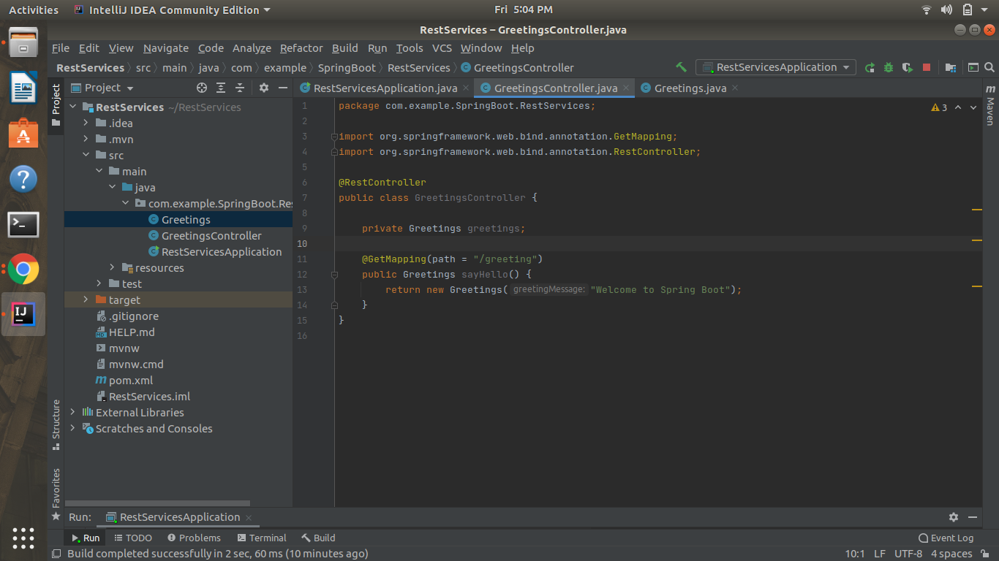

Greetings.java

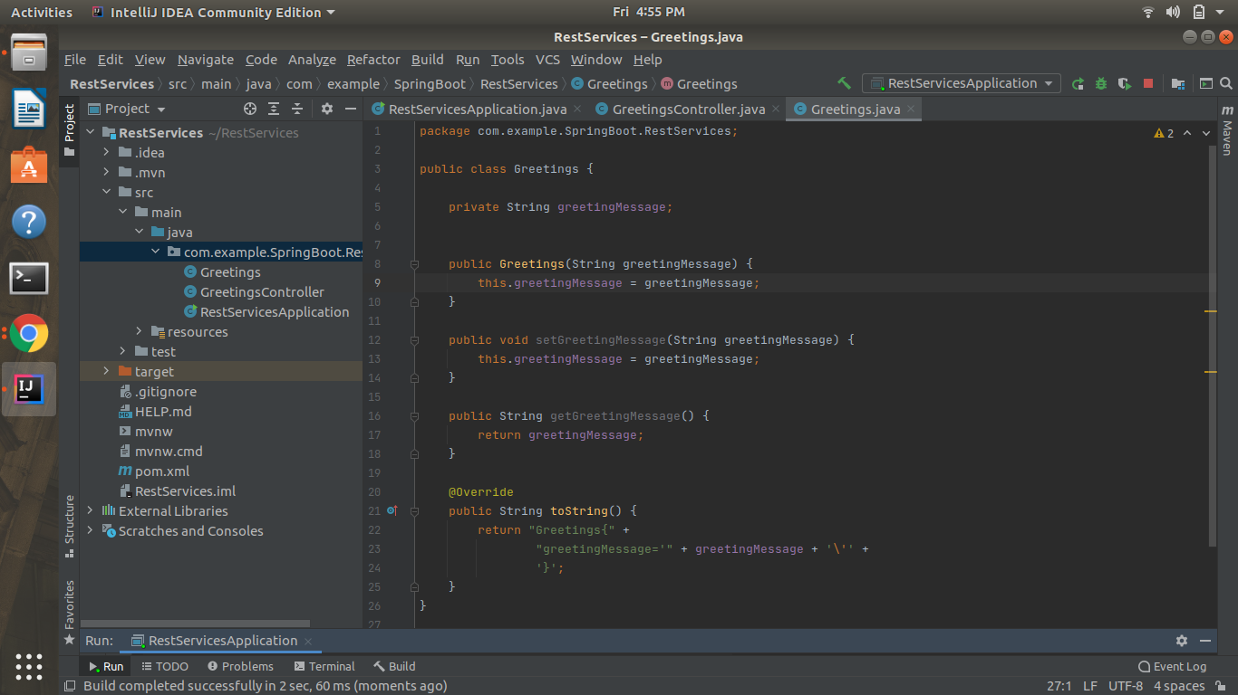

Output(localhost:8080/greeting)

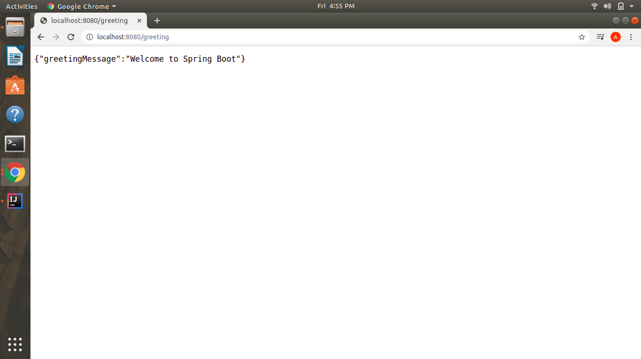

Q2)Create an Employee Bean(id, name, age) and service to perform different operations related to the employee.

Answer-Employee.java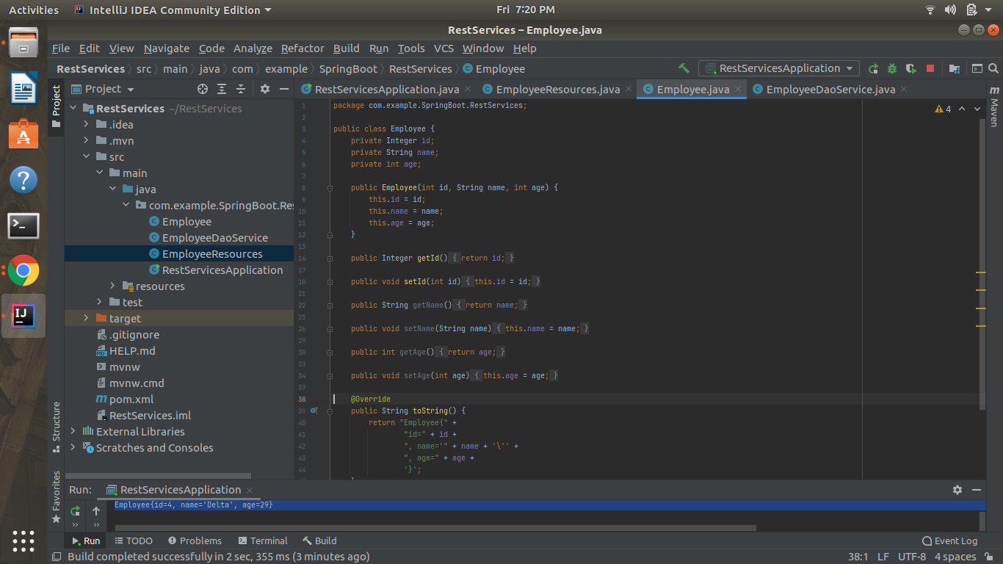

EmployeeDaoService.java

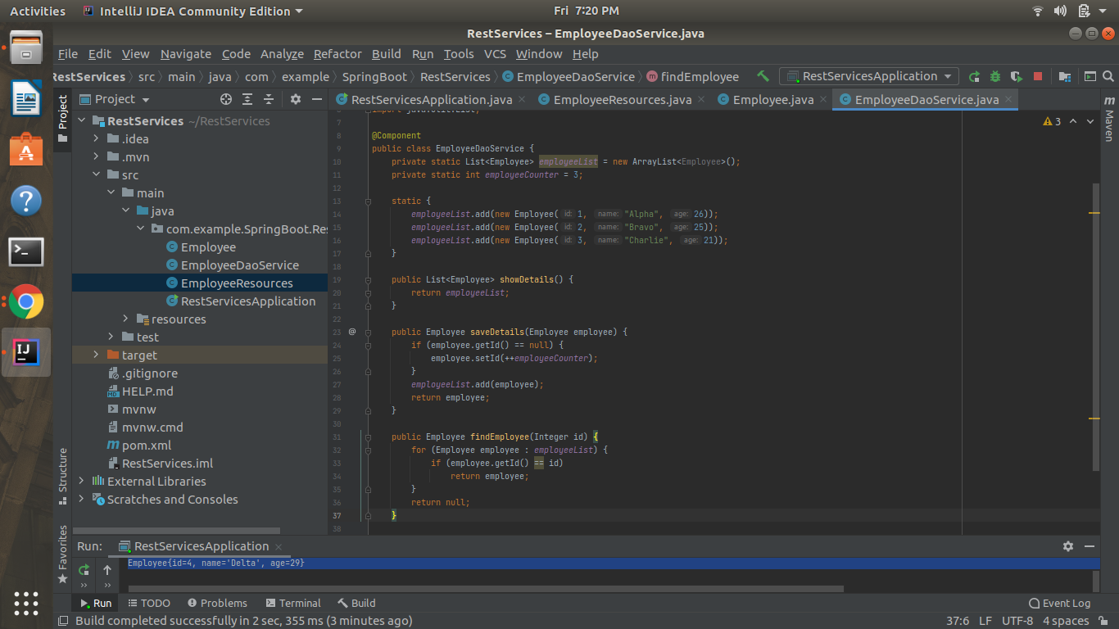

Main class(Output in console)

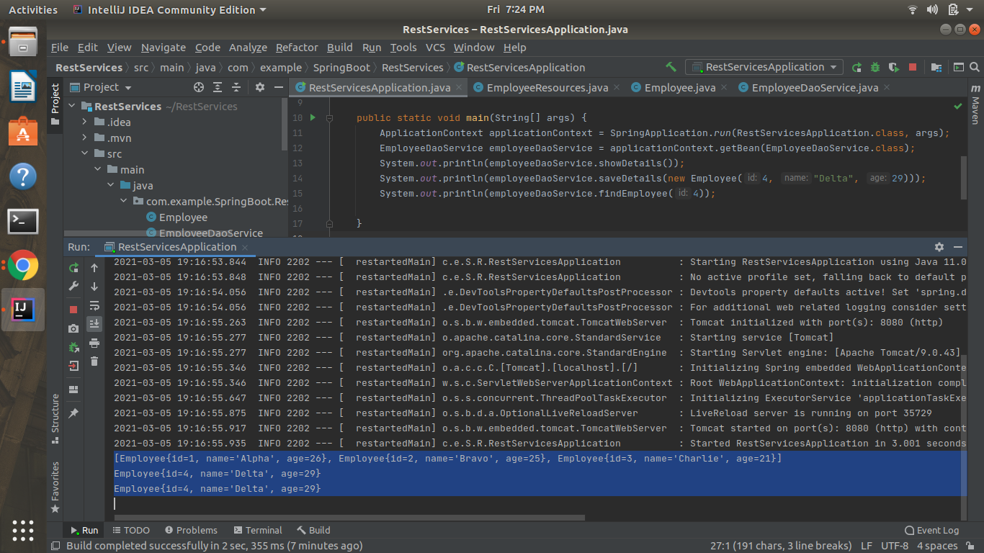

Q3)Implement a GET http request for Employee to get a list of employees.

EmployeeResources.java

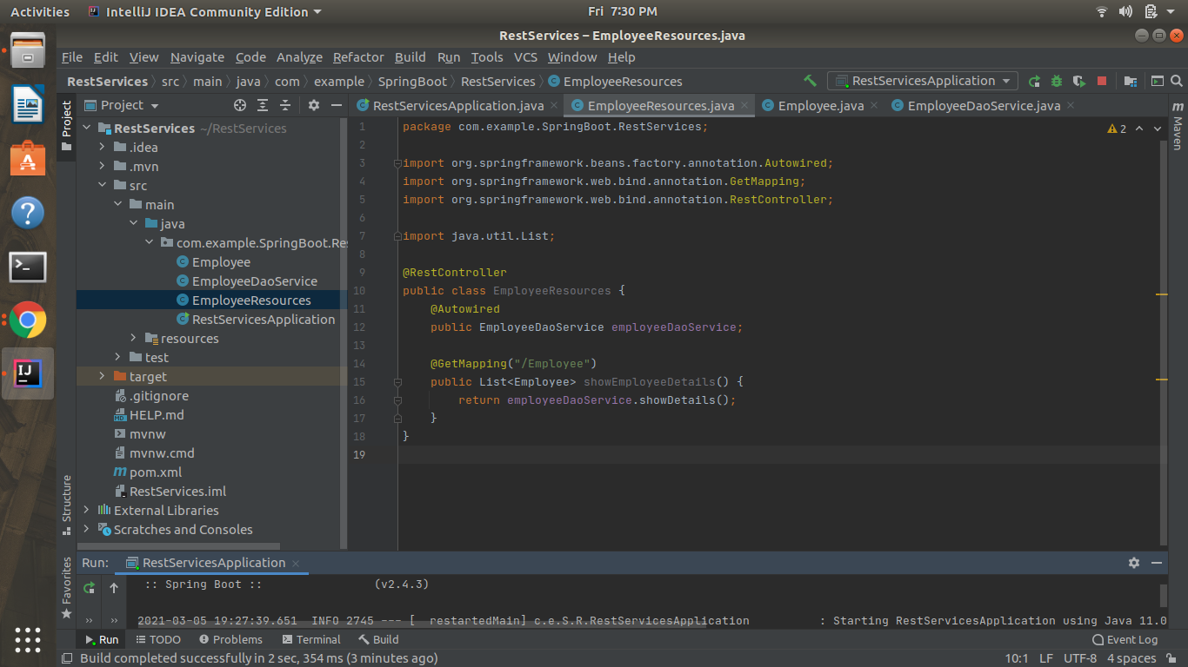

Output(localhost:8080/Employee)

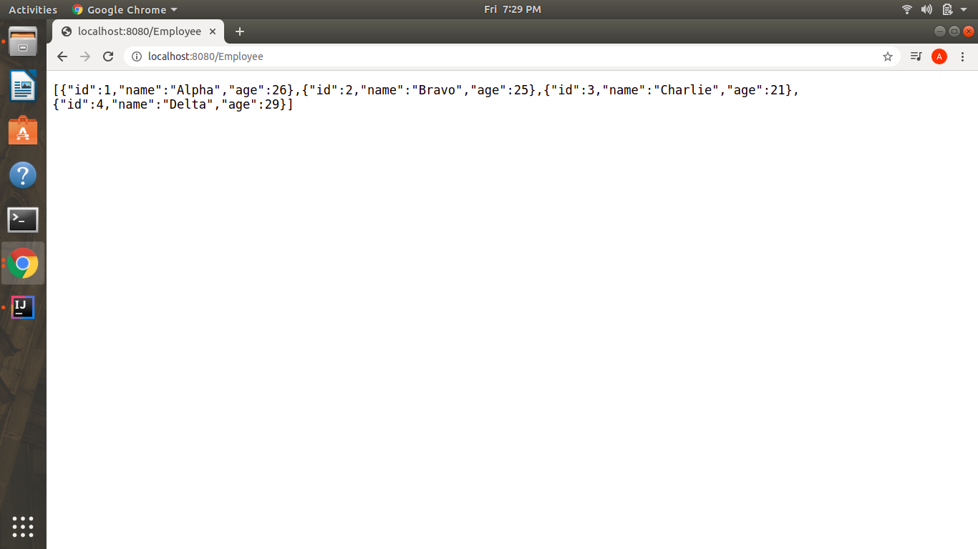

Q4)Implement GET http request using path variable top get one employee

EmployeeResources.java

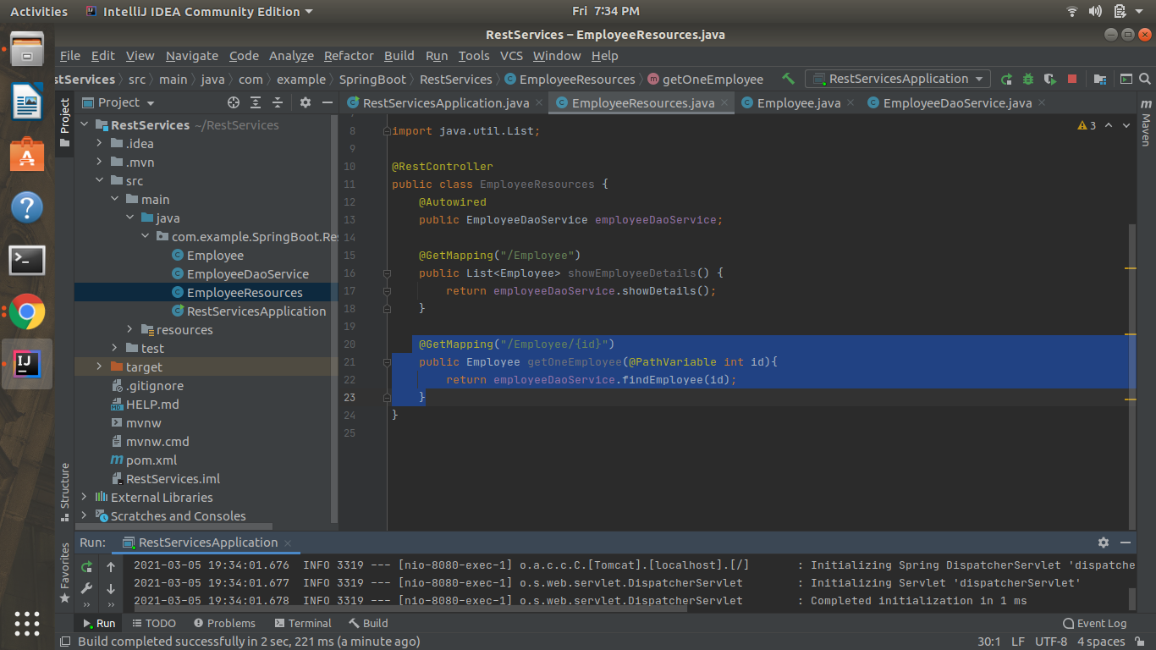

Output(localhost:8080/Employee/2)

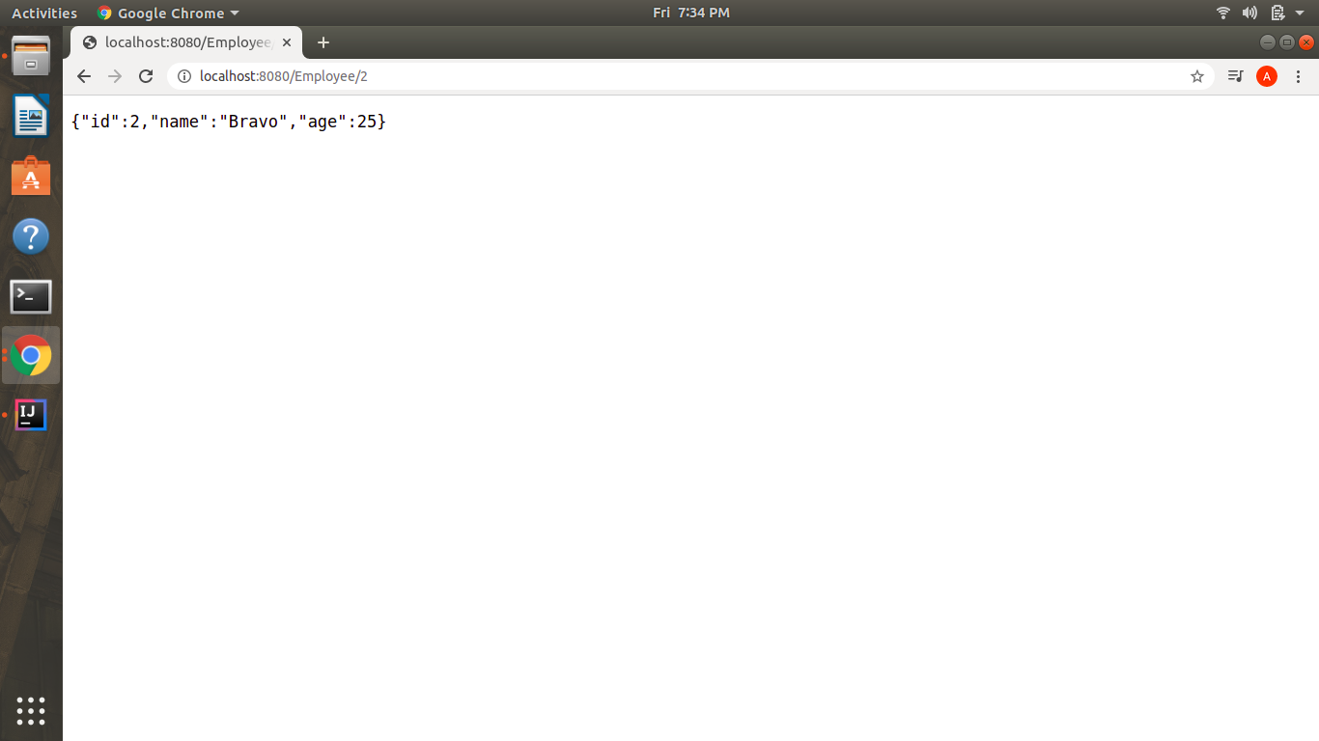

Q5)Implement POST http request for Employee to create a new employee.

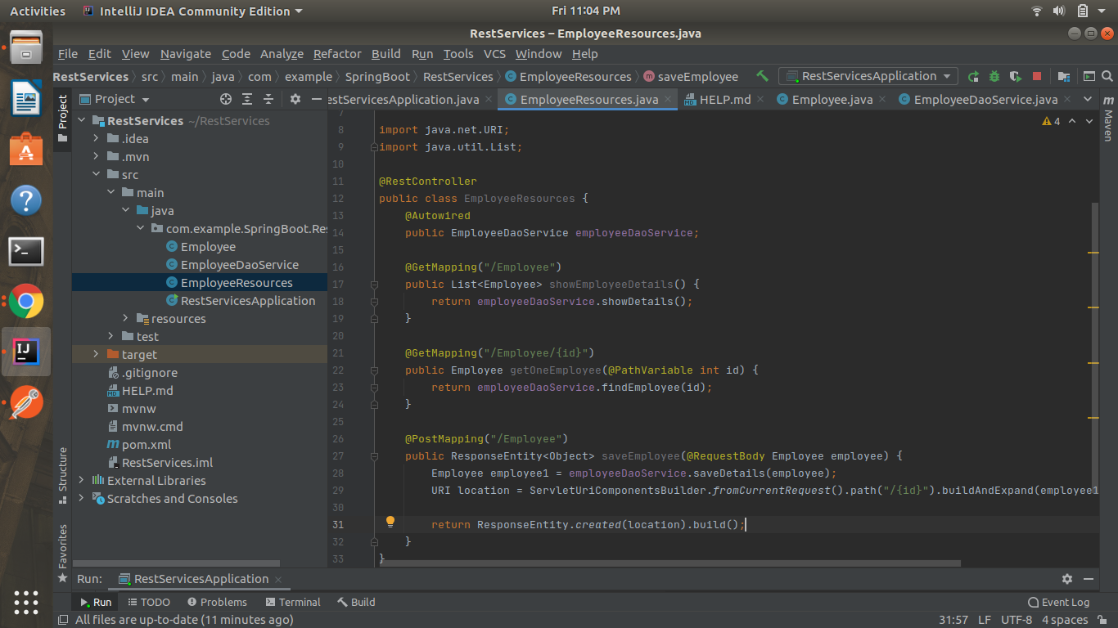

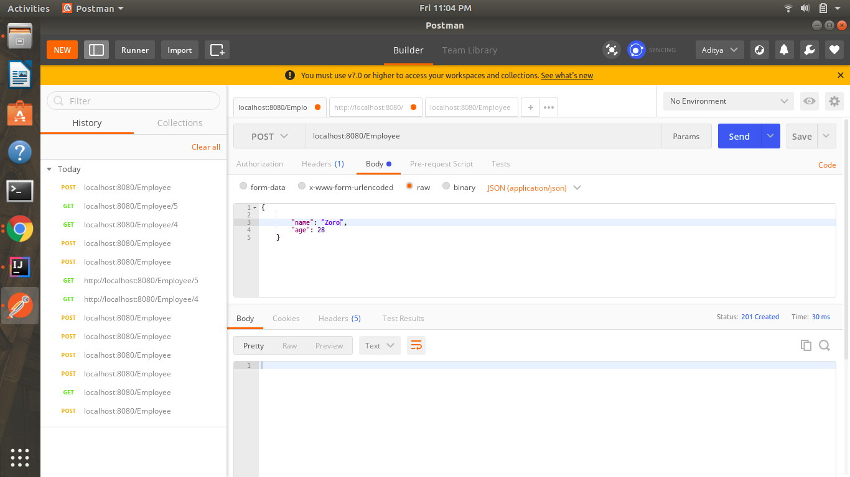

Q6)Implement Exception Handling for resource not found

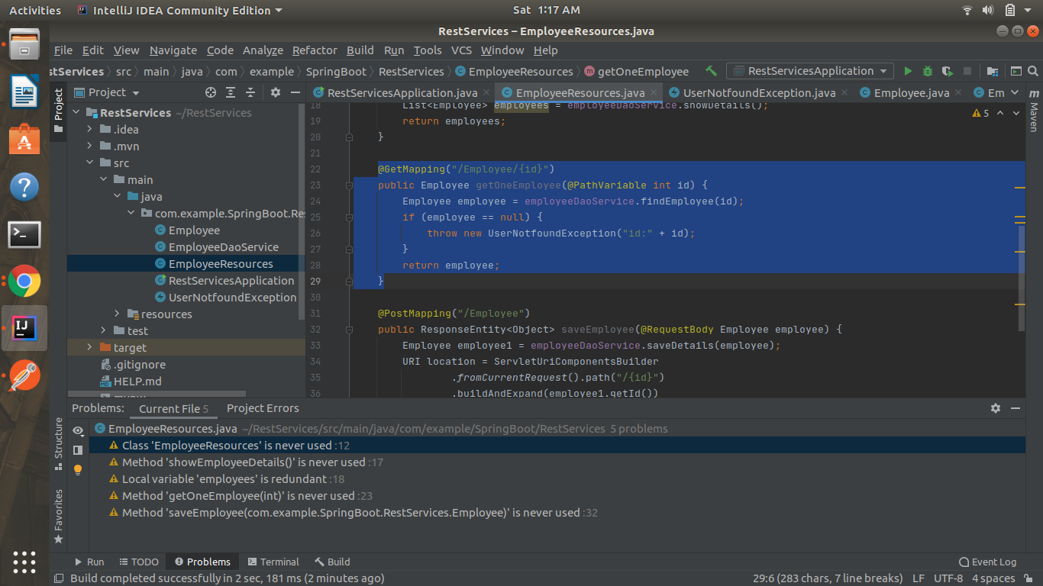

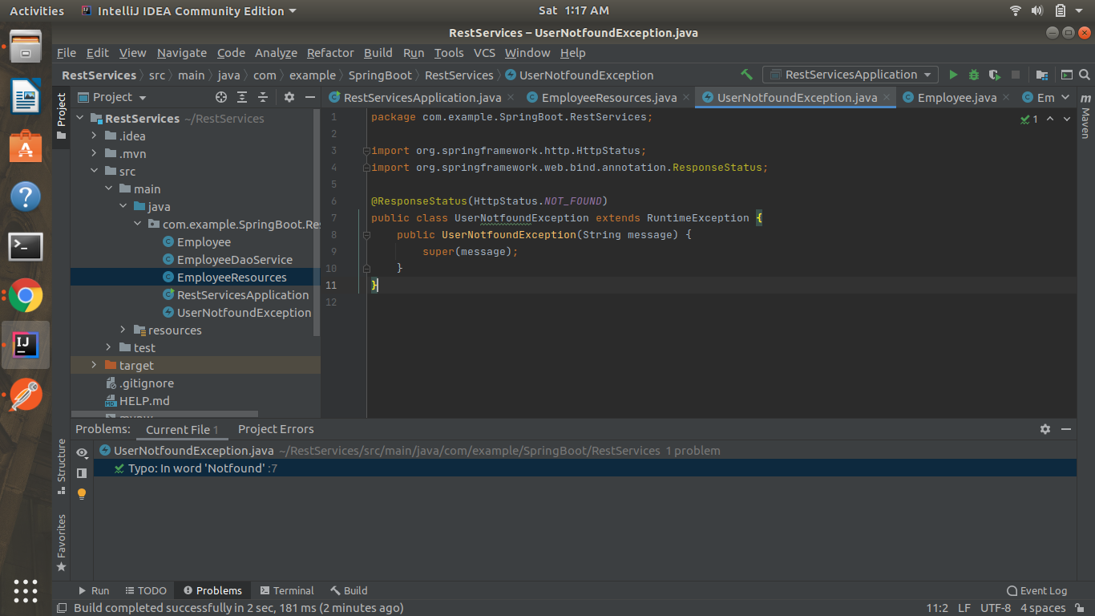

output

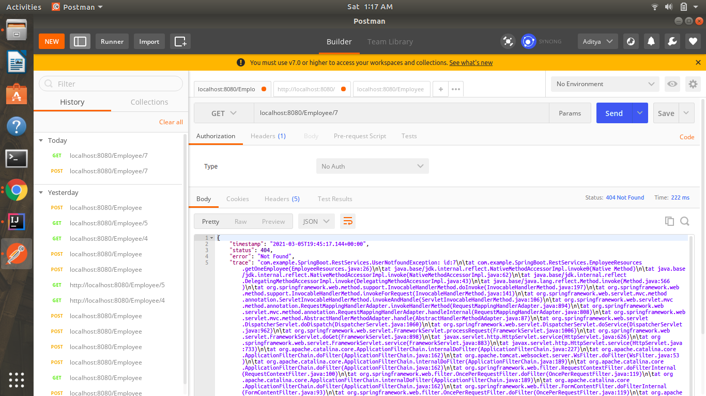

Q7)Implement DELETE http request for Employee to delete employee

EmployeeResources.java

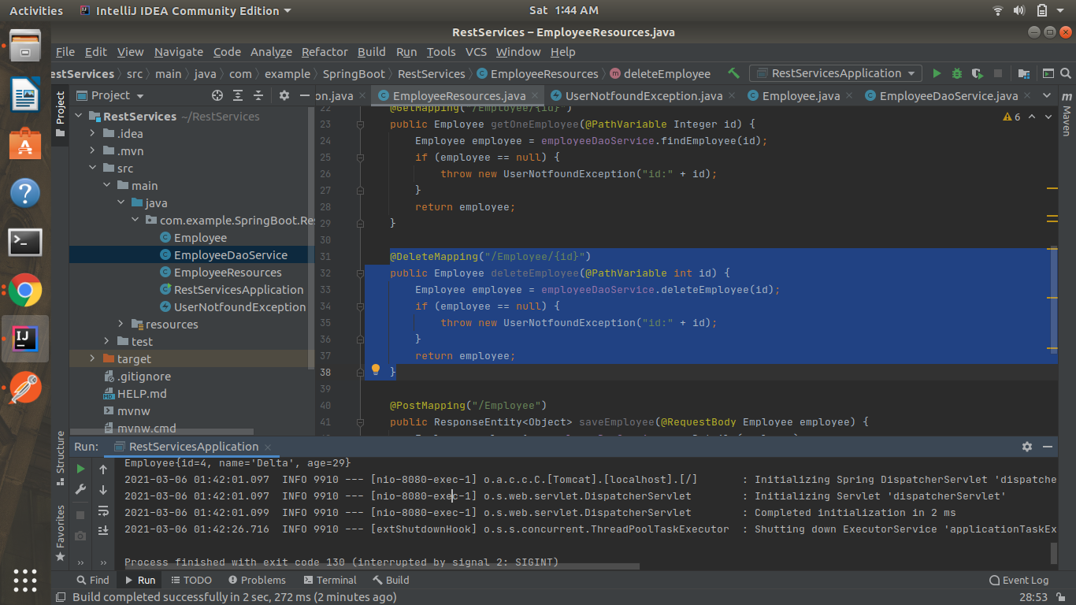

EmployeeDaoService.java

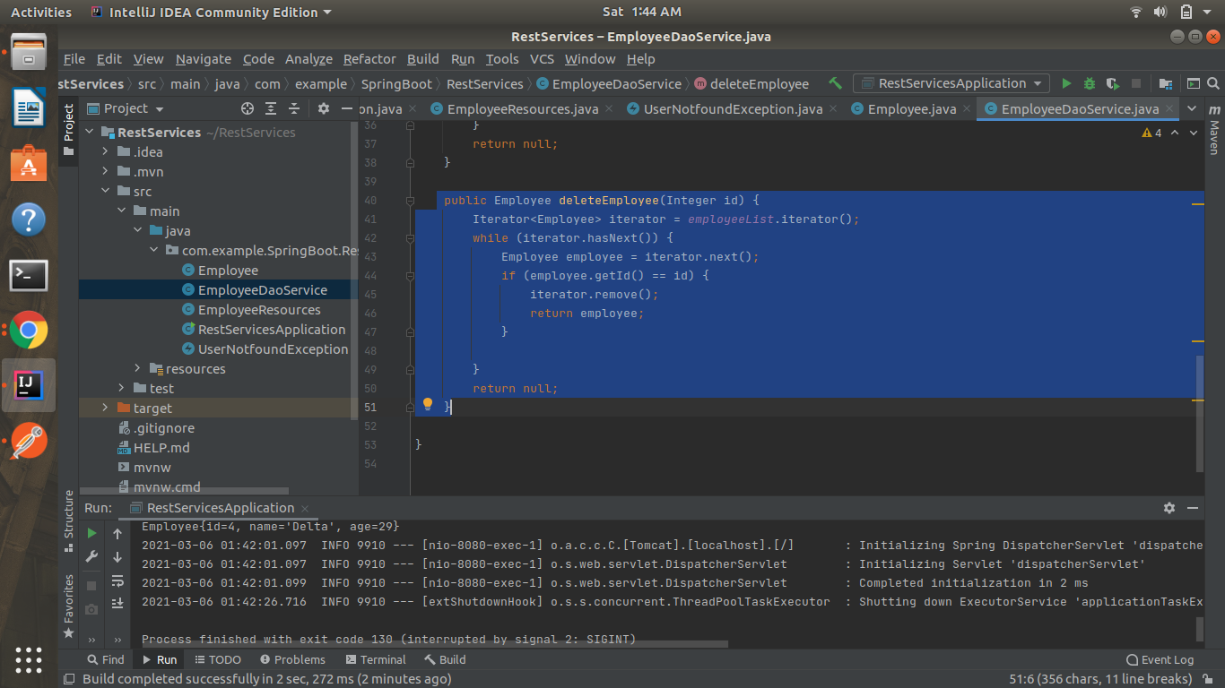

Output of Delete Request

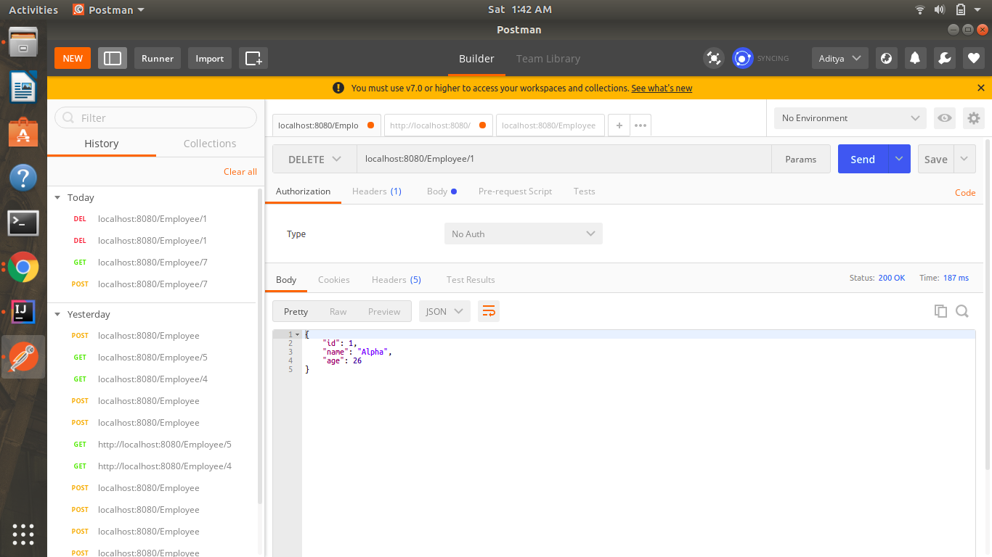

Getting Users’ Details after deleting user with id=1

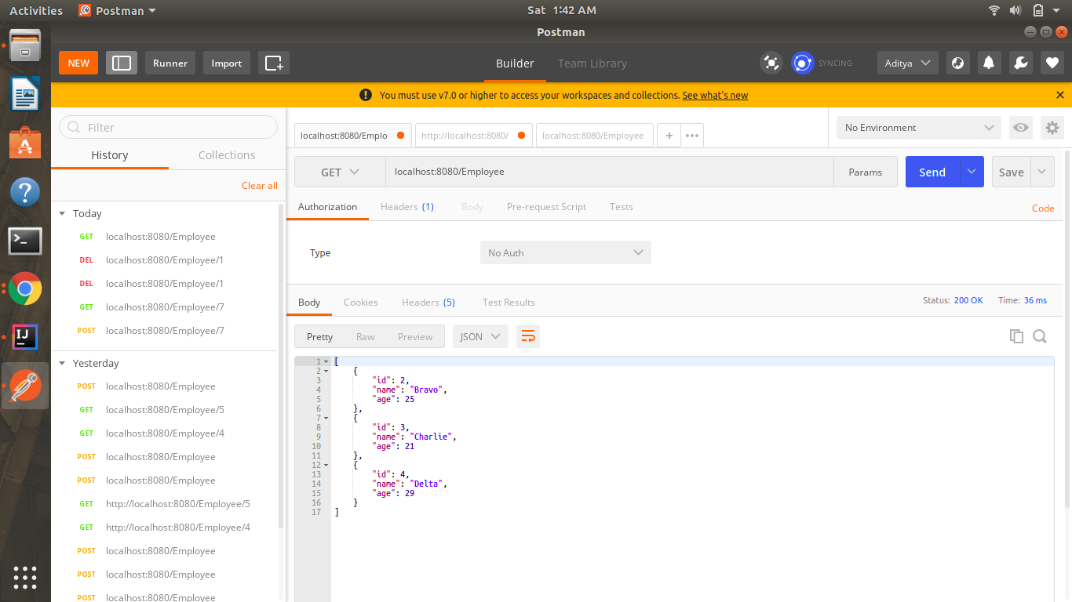

Q8)Implement PUT http request for Employee to update employee.

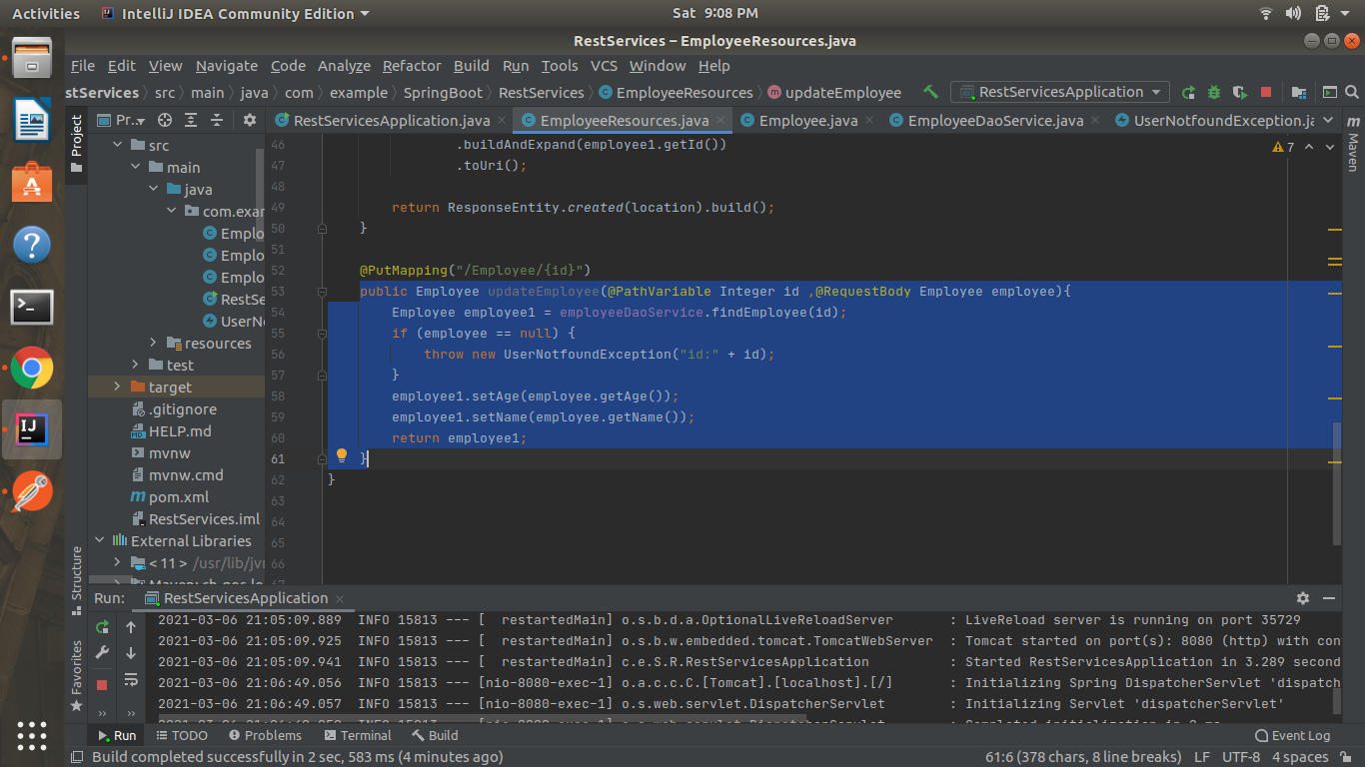

Sending a put request to update a user with id=1

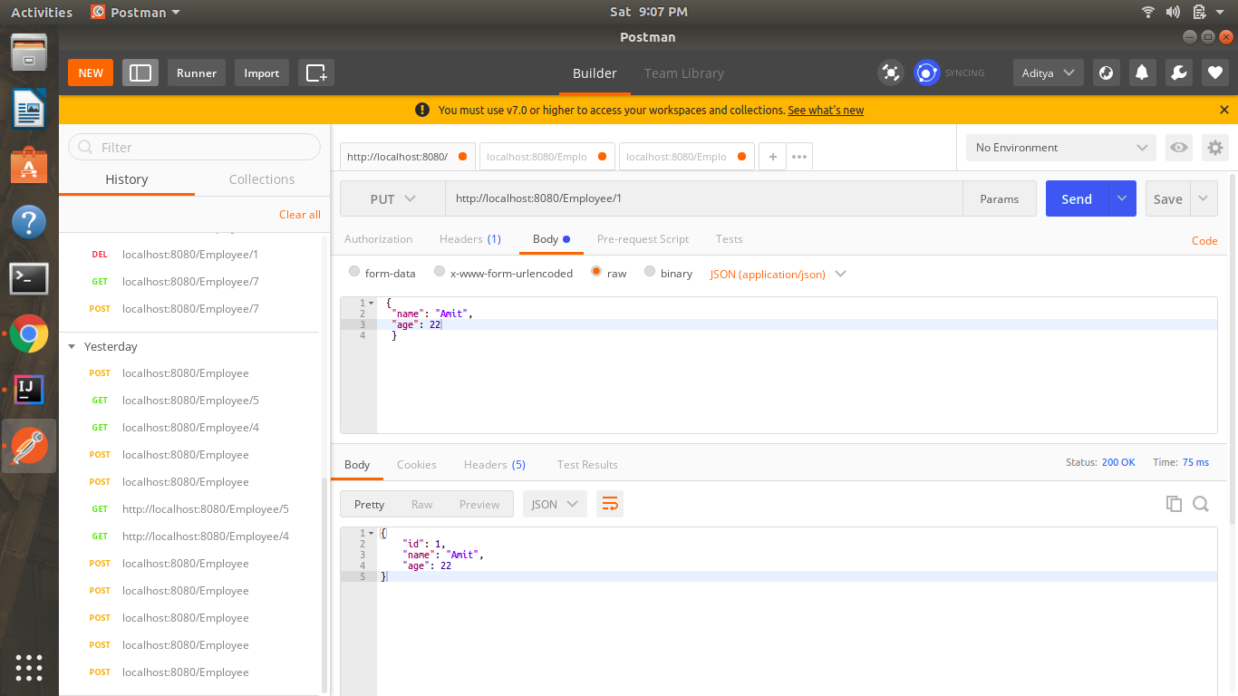

Checking the updated value

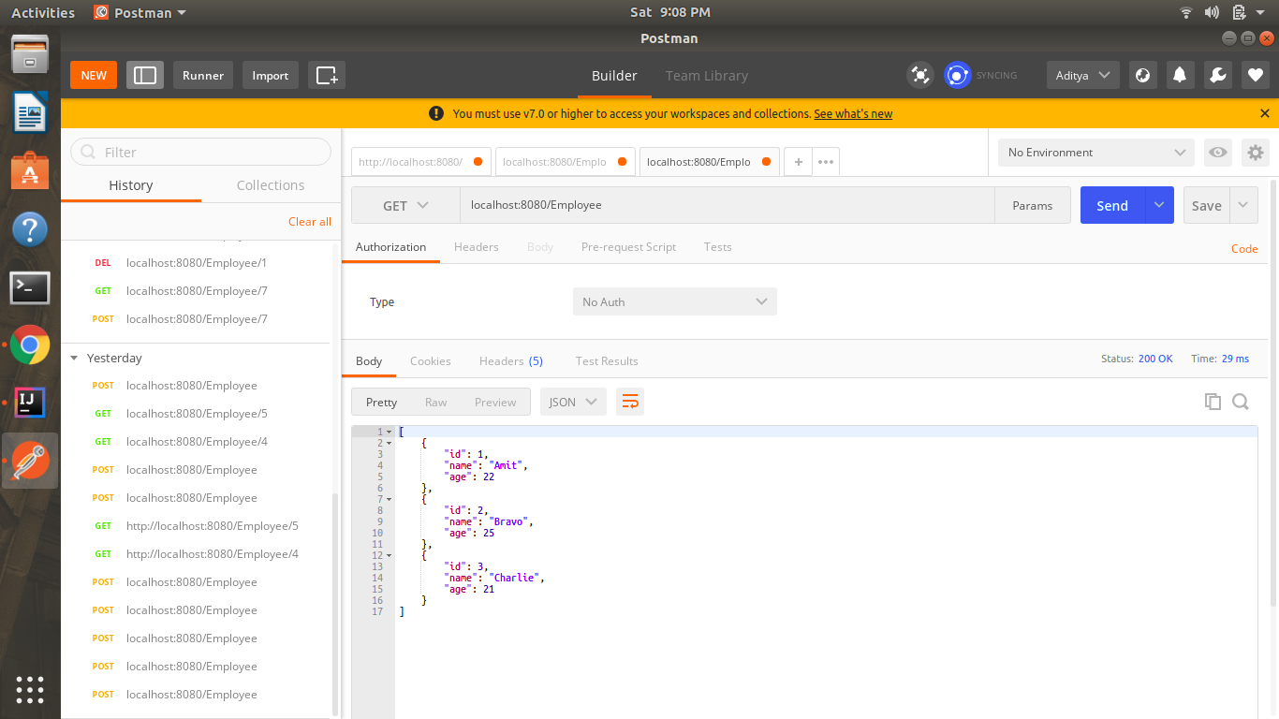

Q9)Apply validation while creating a new employee using POST http Request.

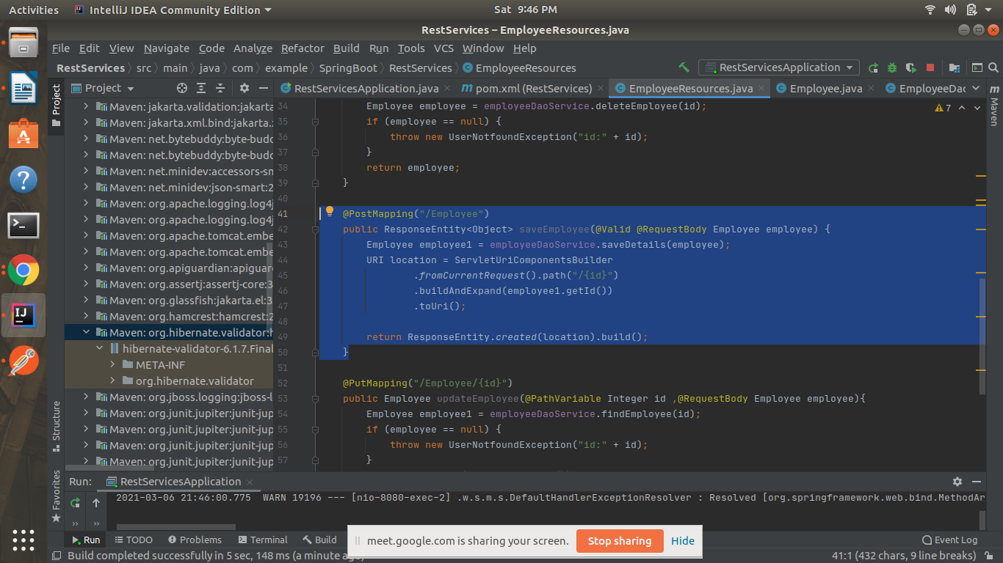

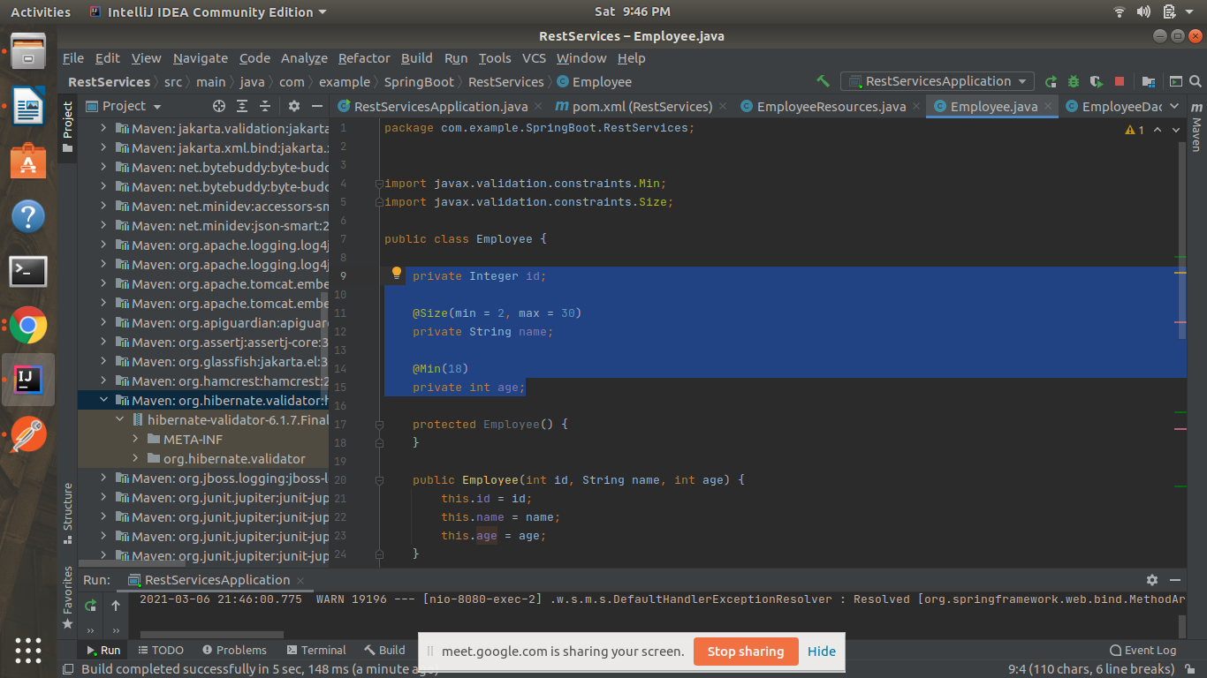

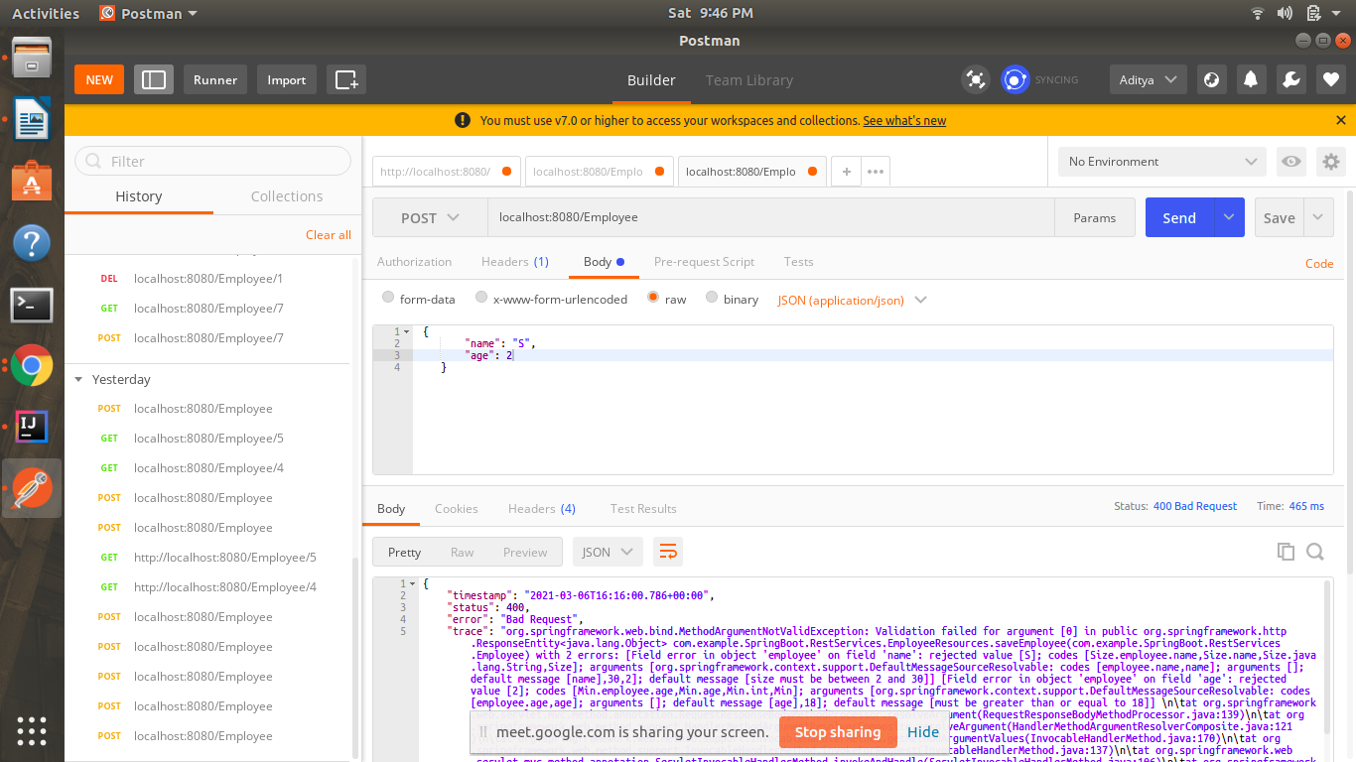

Q10)Configure actuator in your project to check the health of application and get the information about various beans configured in your application

<dependency>

<groupId>org.springframework.boot</groupId>

<artifactId>spring-boot-starter-actuator</artifactId>

</dependency>

http://localhost:8080/actuator/beans

